We are happy to be able to share the opportunity again for St. Teresa of Calcutta families to donate to Operation Christmas Child and put a smile on a child’s face this Christmas. Last year our school community came together for the common good and donated 35 boxes to this charity. Families will have the opportunity to request an ‘Operation Christmas Child Shoebox’ to fill, or families can decorate their own shoebox to fill, or donate items to the school and we will create the shoeboxes on your behalf. Attached is a list of approved/recommended item ideas. There is also information available at https://www.samaritanspurse.ca/what-we-do/operation-christmas-child. The charity also provides the option of creating a shoebox online. Please send a note in with your child(ren) if you would like us to send home an actual ‘Operation Christmas Child Shoebox’ to be filled. Items/boxes must be in to the school by Thursday, November 16, 2017 so that we can ensure that they are packed and labelled to be able to drop off at the collection centre by November 19, 2017. Thank you in advance for your generosity and support. As St. Teresa says, “Together we can do something beautiful for God.”

ABOUT OPERATION CHRISTMAS CHILD

• Operation Christmas Child brings joy and hope to children in desperate circumstances around the world through gift-filled shoeboxes and the message of God’s unconditional love.

• Operation Christmas Child shoeboxes open doors for Samaritan’s Purse to provide children, families, and communities with access to clean water, food, clothing, shelter, medical assistance and more.

• Shoeboxes from Operation Christmas Child transcend all barriers—language, culture, geography, and politics—to give joy and hope to hurting children around the world.

• Each gift-filled shoebox should contain a well-balanced variety of school supplies, toys, hygiene products, and a personal note and photo if you wish. Do not include any candy items.
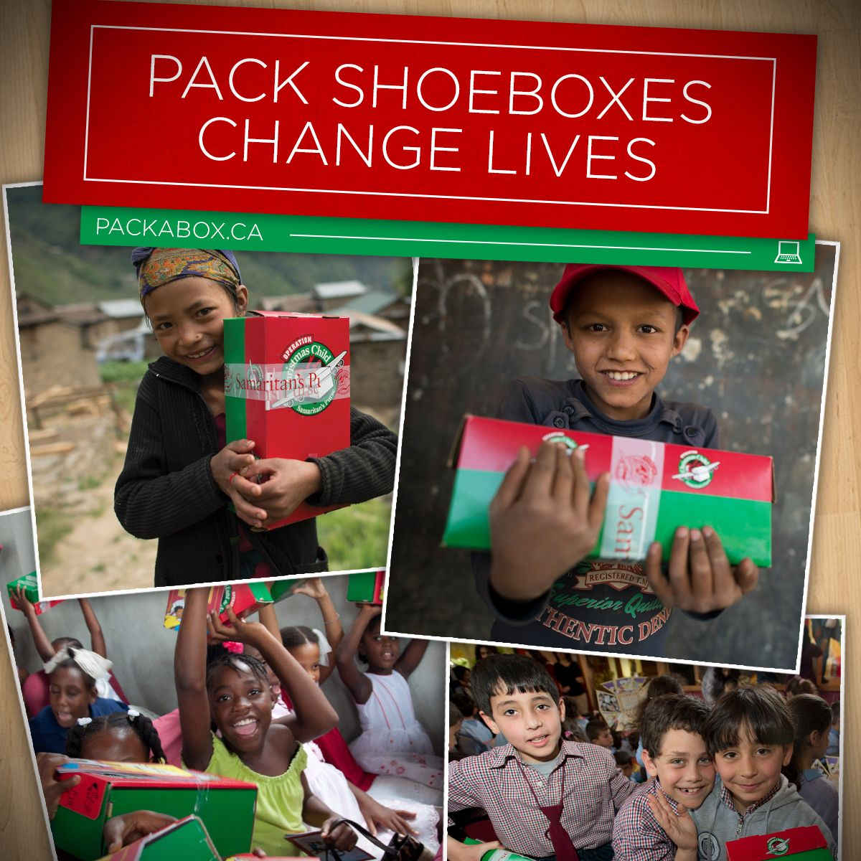

RECOMMENDED SHOEBOX ITEMS

- Baby Powder 38.Ink Pad (Not Liquid) 75. Skipping Ropes
- Baby Wipes/Wet Wipes 39. Jewelry 76. Slime
- Ball 40. Jigsaw Puzzle 77. Slinky
- Balloons 41. Lego 78. Soccer Ball
- Bandages 42. Lined Paper 79. Socks
- Bandanas 43. Magnets 80. Stickers
- Bar of Soap 44. Magnifying Glass 81. String
- Batteries (for flashlight) 45. Markers 82. Sunglasses
- Beads 46. Mirrors (encased) 83. TemporaryTattoos
- Bibles 47. Multi-tool 84. Tennis Balls
- Brush 48. Multi-Colour Sharpies 85. Tools
- Building Blocks 49. Musical Recorder 86. Toothbrush/case
- Calculators 50. Nail Clippers 87. Toques
- Candles 51. Nail File 88. Toy Cars
- Chalk 52. Notepads 89. T-Shirt
- Cloth Bags 53. Oil Pastels 90. Tweezers
- Clothing 54. Paints/solid 91. Underwear
- Coloring Book 55. Pencil Case 92. Wallet
- Comb 56. Pencil Crayons/sharpener 93. Washcloth
- Craft Items 57. Pencils/sharpener 94. Watch
- Crayons 58. Pens 95. Crayons
- Cup 59. Personal Letter 96. Yo-yo
- Dental Floss 60. Picture Book
- Deodorant (Solid Only) 61. Plastic Animals
- Dolls 62. Play Dough
- Erasers 63. Plush Animals DO NOT INCLUDE
- Finger Puppets 64. Purse •food items/candy
- Fishing Kits 65. Razors •used/dirty items
- Flashlight 66. Ruler •liquids
- Flip Flops 67. Sanitary Napkins/Tampons •breakable items
- Foam 68. Scarves •scarey items
- Games 69. Scissors
- Gloves 70. Scribblers
- Glue Stick 71. Sewing Kits
- Hair Accessories 72. Shoes
- Harmonica 73. Shorts
- Hat/Ball Cap 74. Silly Putty

