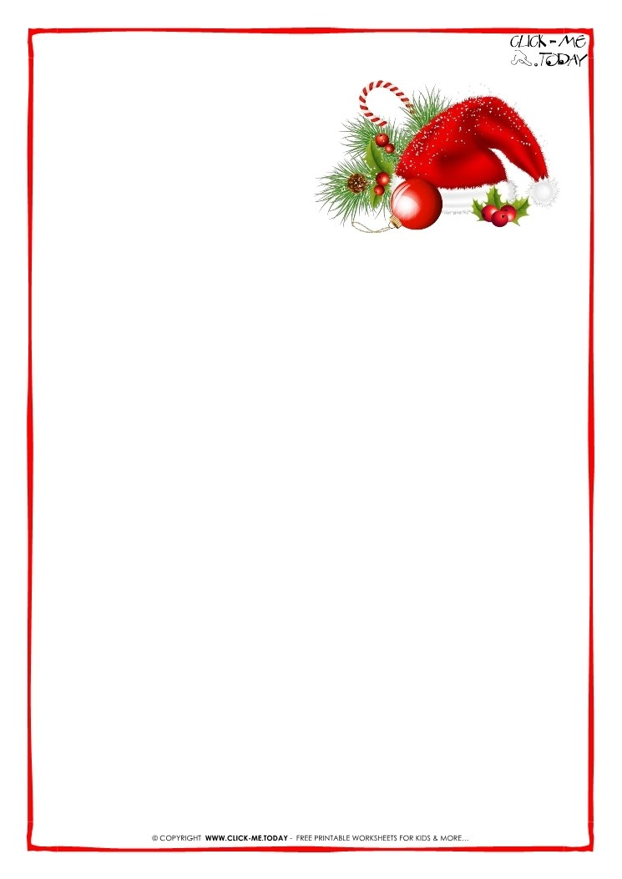

Dear Families,

Parent council presents ‘St. Teresa of Calcutta Milk and Cookies with Santa’.

On **Saturday, December 2nd, 2017** we will be hosting a special holiday event from **10am -12 noon** in our gym. The cost of this event is **$5.00** per child. Your family will receive one family photo with Santa, each child will be able to participate in a holiday craft and enjoy a little snack which will include either milk or juice and a cookie.

No outside food is permitted. This is to help ensure the safety of others, as we are a nut safe school.

Hope to see everyone there as we look forward to meeting you and sharing holiday spirit.

Please return the bottom portion of the form no later than November 24th, 2017. Please make cheques payable to St. Teresa of Calcutta. Please remember to put your child’s name on the back of the cheque.

Family Name:____________________________________

# of children: _ _________________________________

Oldest child’s classroom teacher ________________________